Atitit main函数的ast分析 数组参数调用的ast astview解析

1.1. Main 的调用语句ast view 1

1.2. ArrayCreation 3

1.3. ArrayInitializer 3

## Main 的调用语句ast view

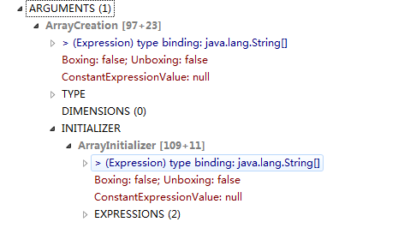

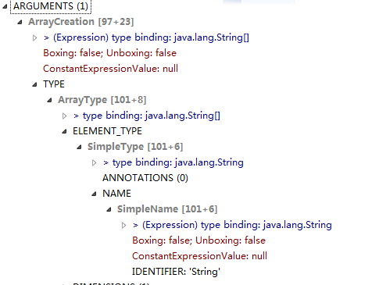

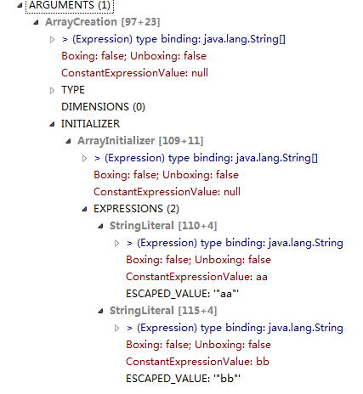

## ArrayCreation

/AtiPlatf_cms/src/com/attilax/ast/ArrayCreation.java

**public** **class** ArrayCreation **extends** Expression {

**public** String arrayType; //String

//public ASTNode.NodeList dimensions;

**public** ArrayInitializer optionalInitializer;

**public** **static** **void** main(String[] args) {

// **TODO** Auto-generated method stub

}

## ArrayInitializer

**package** com.attilax.ast;

**import** java.util.List;

//import org.eclipse.jdt.core.dom.AST;

//import org.eclipse.jdt.core.dom.ASTNode;

//import org.eclipse.jdt.core.dom.Expression;

**public** **class** ArrayInitializer **extends** Expression {

**public** List expressions;

}

## Jdt ArrayInitializer htod expressions yashge list..nodelist ext from list...